DS 2003: R and RStudio Installation

# **Introduction**

Welcome to DS 2003: Communicating with Data

Note that, for now, I assume students have a laptop or desktop computer on which they can install programs. We will be installing R and RStudio. This should all work on a Mac or Windows machine.

Let’s get started!

# **Getting your environment ready**

Ris an open source statistical analysis/computing environment. R's rapid growth in use places it among the most popular statistical analysis software. Much of R's popularity stems from it being open source (and free!) together with its extensible nature. As a programming language, Rhas become prominent in recent years as a tool for performing high level analytics. As a programming language, Rhas begun borrowing many tools from the programming world. One of the most prominent among them is R Studio, a free, open source and user-friendly integrated development environment (IDE). An integrated development environment is a tool designed specifically for developing code and analyses using a computer language. In the case of RStudio, the environment is specifically designed for developing "data products" using R.

For this course, we'll be using RStudio for creating open and re-usable code for statistical analysis. You'll need to:

* + Install [R for Windows](https://cran.r-project.org/bin/windows/base/) and [R for Mac](https://cran.r-project.org/bin/macosx/)
  + Install [RStudio](https://www.rstudio.com/products/rstudio/download/) on your computer

# **Install R**

* Click link: [R for Windows](https://cran.r-project.org/bin/windows/base/) -or- [R for Mac](https://cran.r-project.org/bin/macosx/)  [download most recent R]
* *Note that the most recent R version may be different*

For Windows:

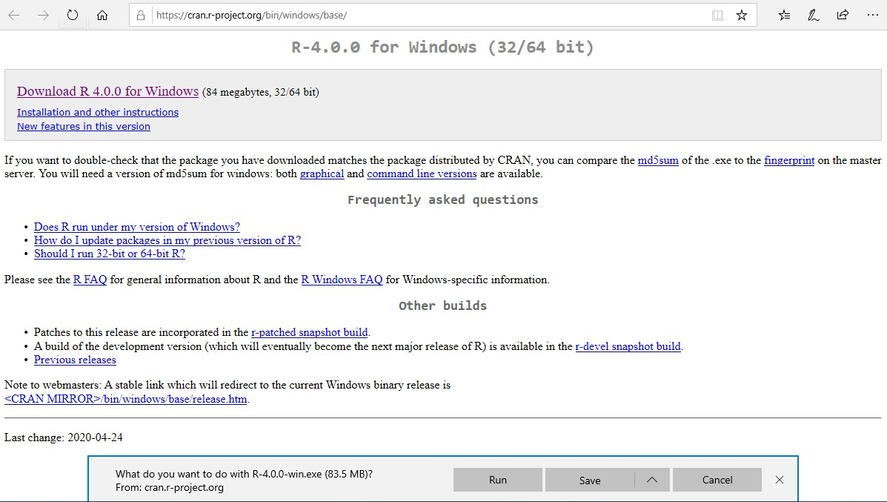

1. Click download

2. Click save

Click view downloads (or go to downloads folder) and click R-4.0.0-win.exe *(your version will be different)*

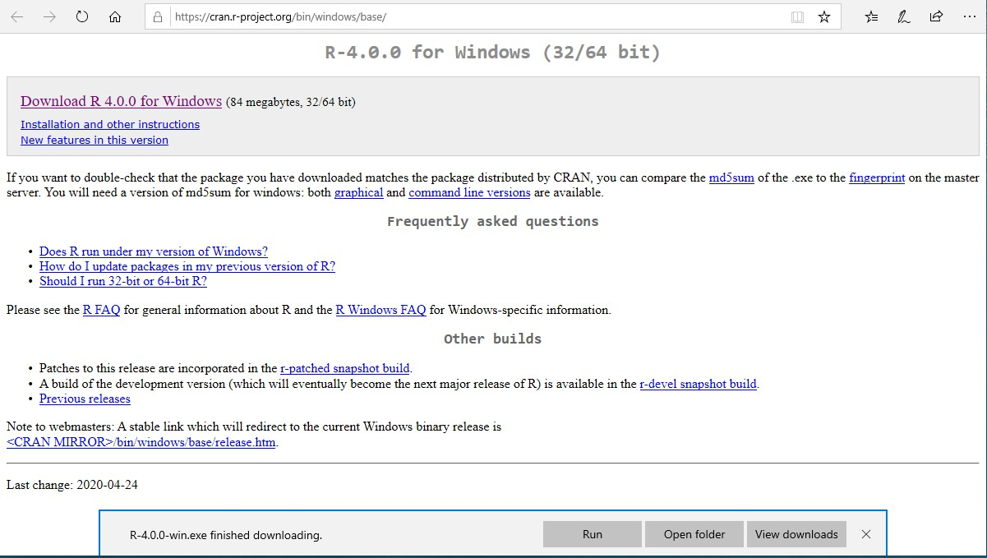

3. Click view downloads

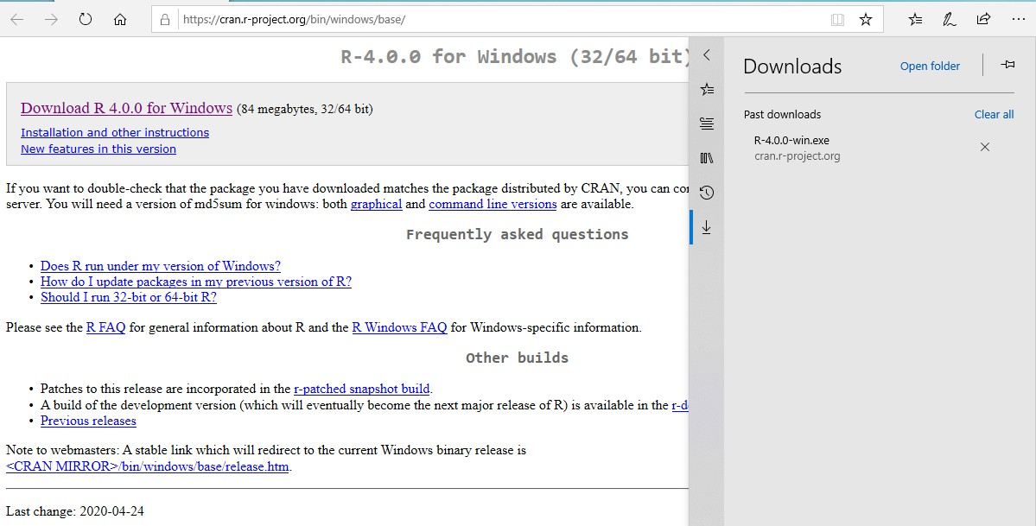

Finish by following the instruction on your machine

For Mac:

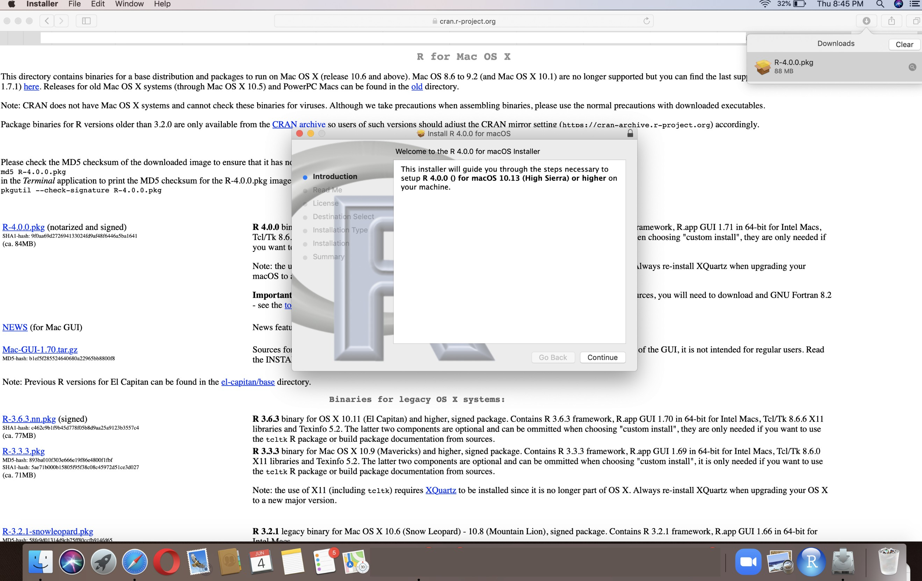

1. Click downloaded pkg

1. Click link

1. Click continue

Finish by following the instruction on your machine

1. **Install RStudio**
   1. Click link: [RStudio](https://www.rstudio.com/products/rstudio/download/)
   2. Click FREE download

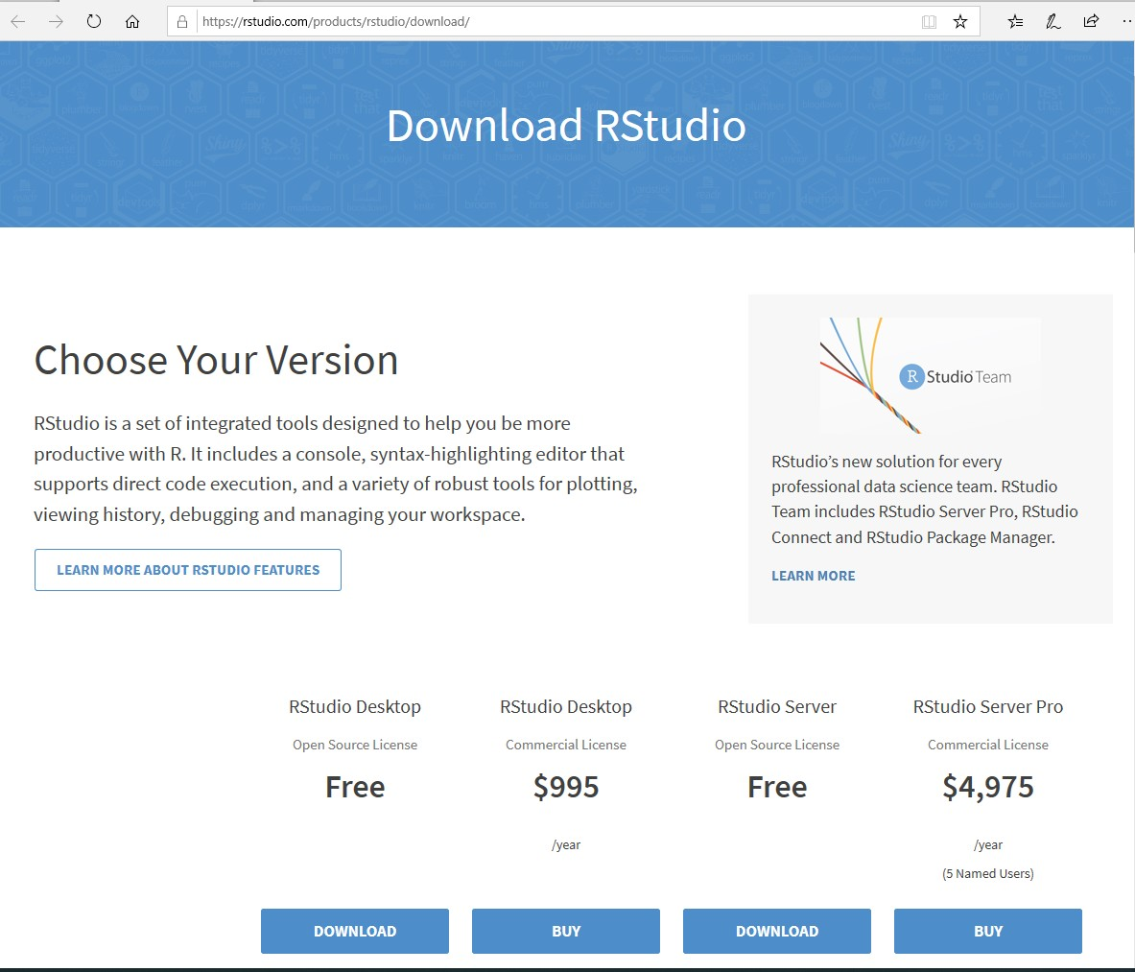

1. Click download

Click Windows or MacOS link -> Click Save

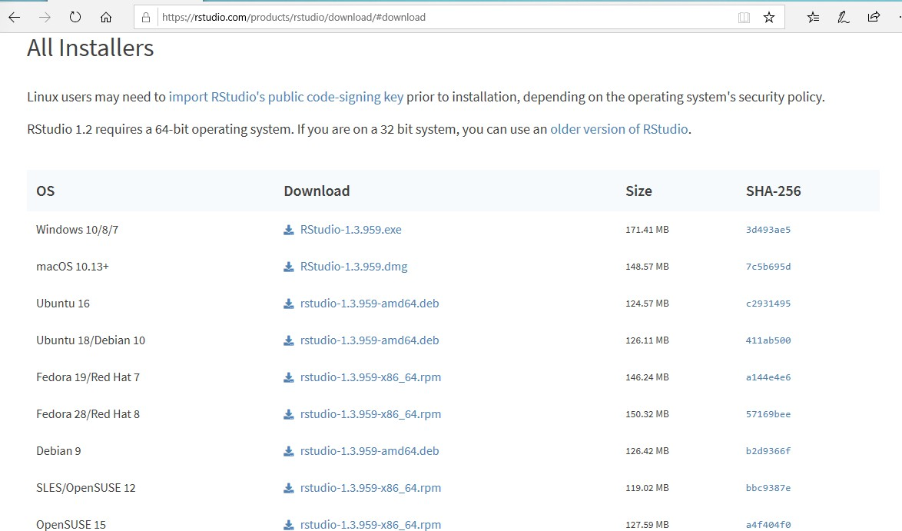

2. Click windows link (or macOS link for Mac)

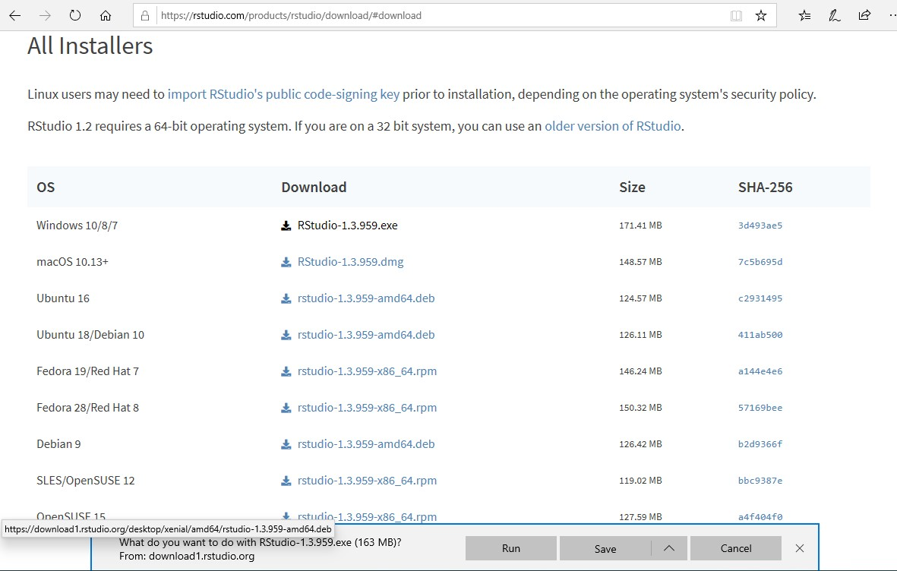

3. Click save

Click view downloads (or go to the downloads folder) and click RStudio-1.3.959.exe

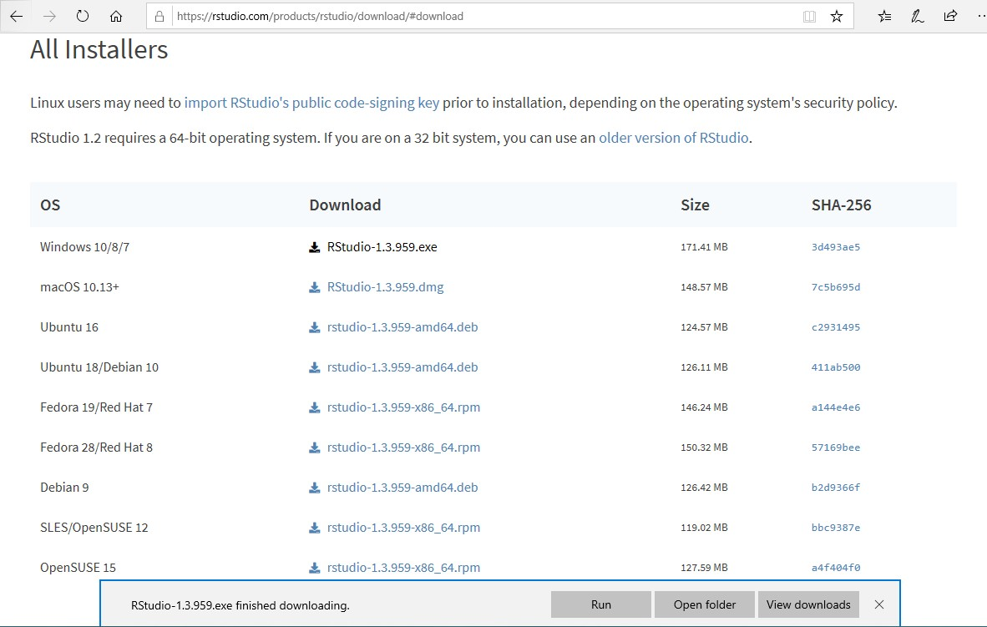

4. Click view downloads

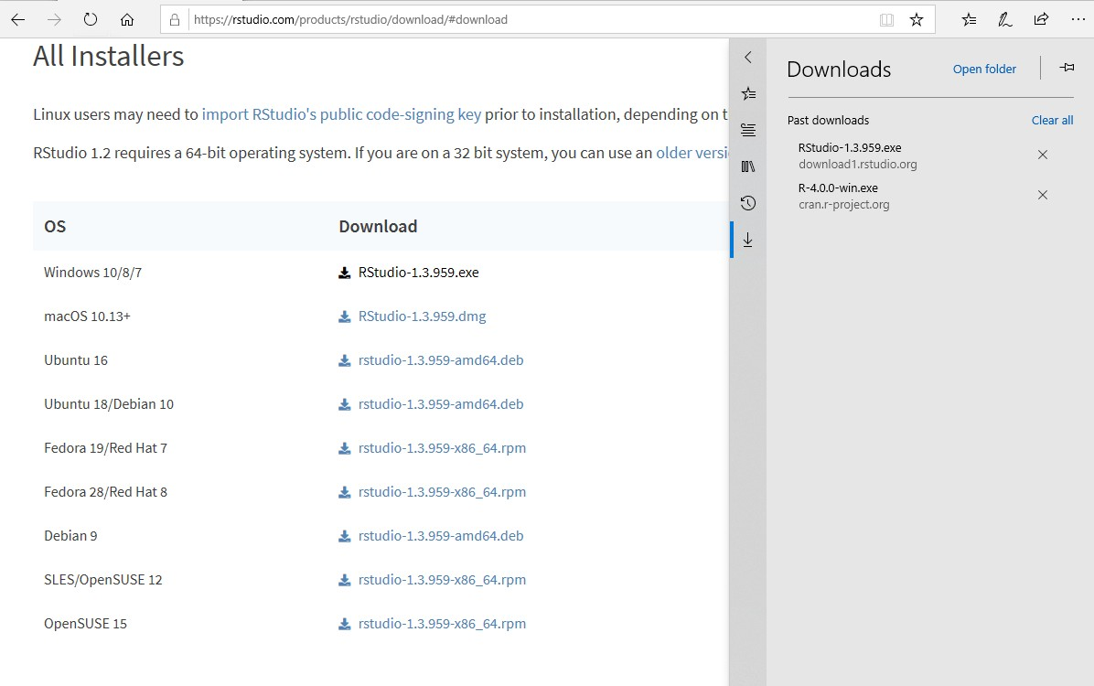

Follow the instructions that appear on your screen